06/06/2022
Agenda:
- What is web Service?
- Basic Concept behind web service?
- Why we use it?
Project Application:
- Front End(UI)
- Backend (Database)
- Service(API)
Web Service:
- Service available over the web
- Waiter: Who is doing communication between you and Kitchen
- Waiter: Waiter is performing the role of Web Service through an API.
- We can say he(waiter) is communicating between two applications and making sure that the communication between two applications is proper.
Kitchen (Chef)(Service Provider)
You (Service Consumer)
Waiter (API)

Web Service:
- Service available over the web
- Enables communication between applications over the web
- Platform independent communication
- Provides a standard protocol/format for communications
- Using Web service two different applications can talk to each other and exchange data/information
- An API is the acronym for Application Programming Interface, which is software intermediary that allows two applications to talk to each other
- Each time you use an APP like Facebook, Send an instant message or check weather on your phone, you are using an API.
- Web Service is an Application or business logic
- Web Service allows you to expose the functionality of your existing code over the network. Once it is exposed on the network, other applications can use the functionality of your program.
What is API?
User Layer or Presentation Layer
Business Layer (API)
Database Layer

Client (Service Consumer)
Server (Service Provider)
Request
Response

Medium: HTTP
Format: XML/JSON
Types of Web Services:
- SOAP Service(Simple Object Access Protocol): XML Language
- REST Service(Representational State Transfer): JSON Language
Components/Specifications/Standards of SOAP Web Service: WSDL, UDDI, SOAP
WSDL: Web Service Description Language
- WSDL stands for web service description Language
- WSDL is the standard format for describing a web service
- WSDL is pronounced as ‘wiz-dull’ and spelled out as W-S-D-L
- WSDL definition describes how to access a web service and what operations it will perform.
- A client program connecting to a web service can read WSDL to determine what functions are available on the server.
- WSDL is an XML document with a <definitions> element at the root and the child elements
<types>,
<message>,
<portType>,
<binding>
- Web Service description language is an xml based interface that is used to describe the functionalities of the web service
- Consumer needs to know what services available are ?.What are the request response parameters?. How to call a web service?
<definitions>:
- Element must be the root element of all WSDL documents
- It defines the name of the web service
- The definitions element is container of all other elements.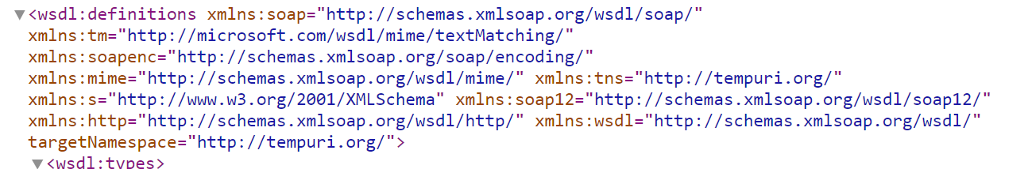
<types>:
- WSDL <types> element take care of defining the data types that are used by the web service
- WSDL allows the types to be defined in separate elements so that the types are reusable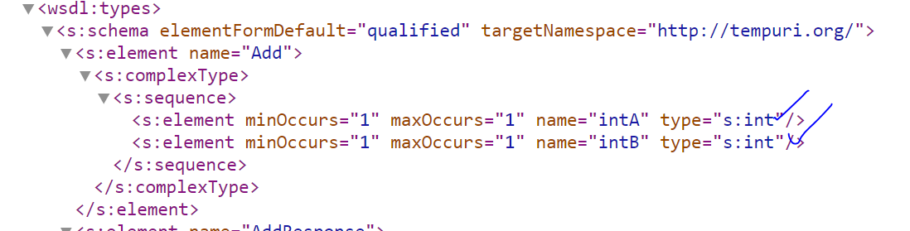
<message>:
- The <message> element describes the data being exchanged between the web service providers and consumers
- Each Web Service has two messages: Input and Output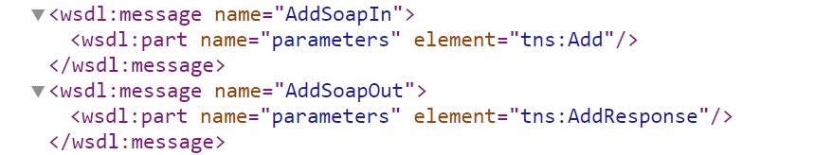
<portType>:
- <portType> can combine one request and one response message into a single request/response operations
- A Port type can define multiple operations
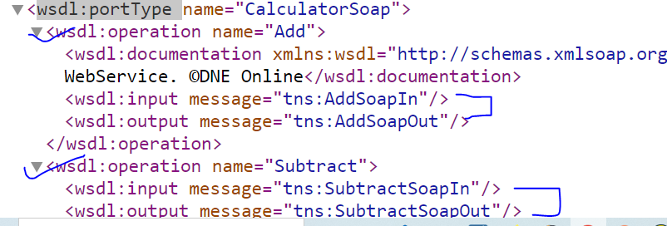
<binding>:
- To Combine all operations together
- The <binding> element provides specific details on how a port Type operation will actually be transmitted over the web.
WSDL File: <definitions>,<types>,<message>,<portType>,<binding>
UDDI: Universal Description discovery Integration
- Universal Description discovery integration is an XML based standard for publishing and finding web services
- A web service provider publishes his web service(Through WSDL) on an online directory from where consumers can query & search the web services
- This is online registry/directory is called UDDI.
WSDL
WSDL
WSDL
WSDL
UDDI

Web Service:
- SOAP Service
- REST Service
SOAP Web Service:
- A web service that complies to a SOAP web service specifications is a SOAP Service.
What are these specifications/Standards?
- Basic Specifications: WSDL,UDDI,SOAP
Who defines and dictates these specifications?
- W3c(world wide web consortium)
SOAP: Simple Object Access Protocol (Protocol)
- SOAP is an XML based protocol for exchanging information between web services
- SOAP is a communication Protocol
- SOAP provides data transport for web services
https://www.soapui.org/downloads/soapui/
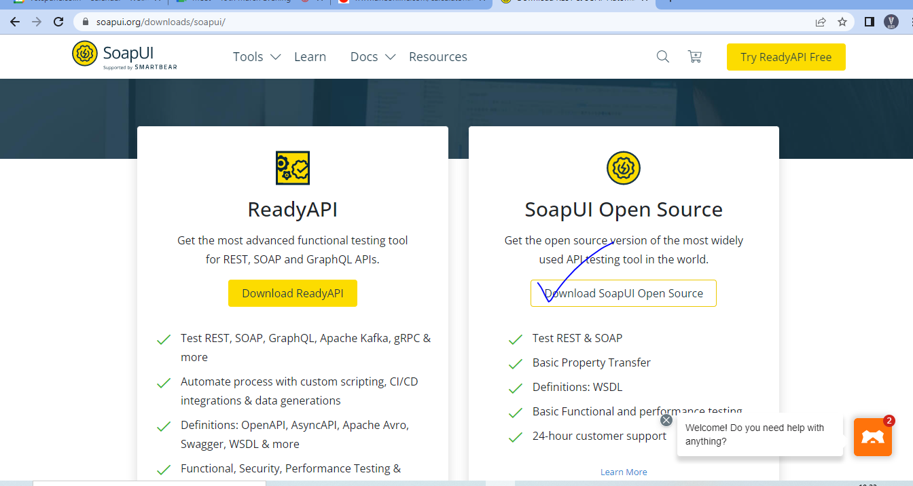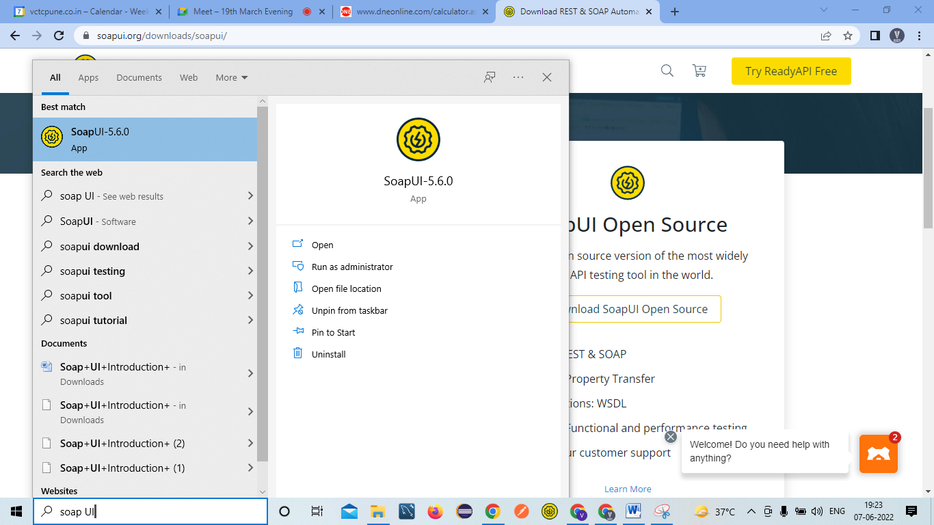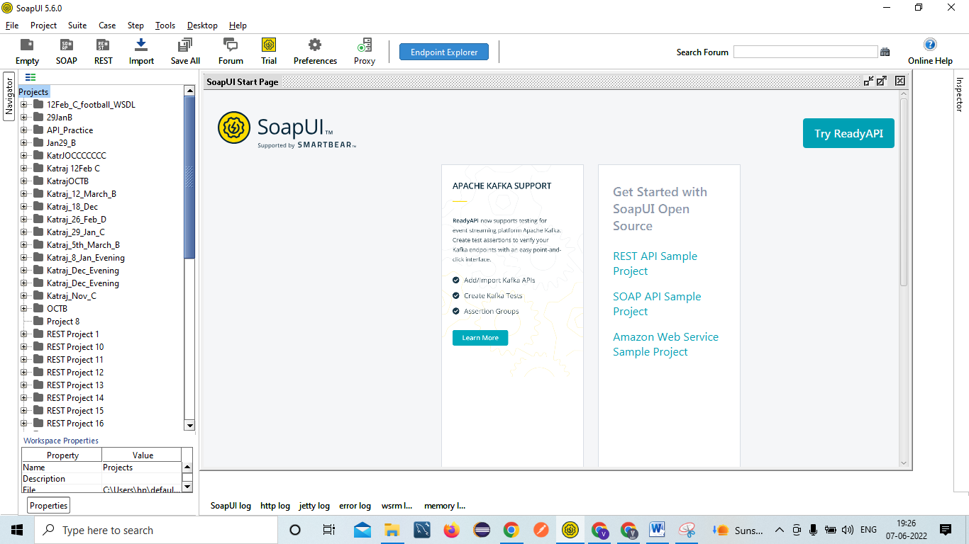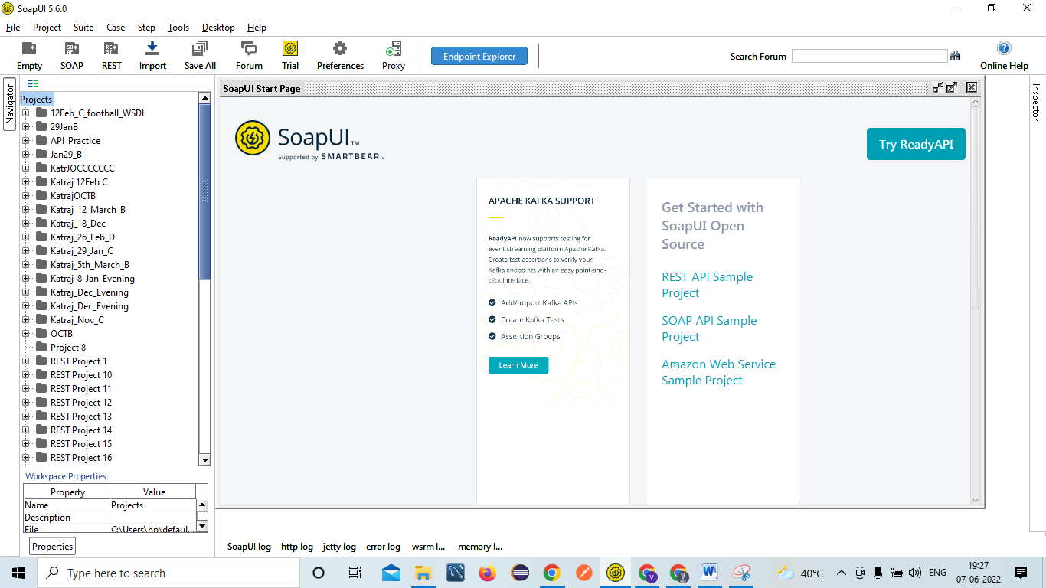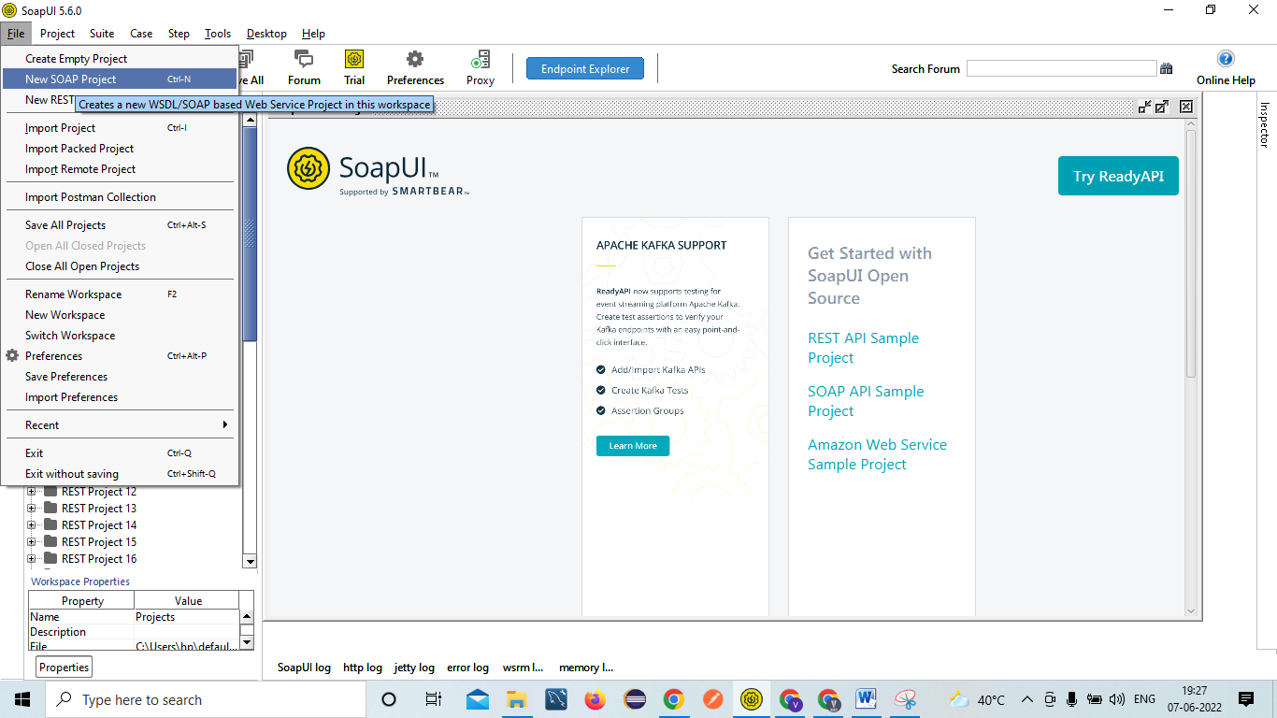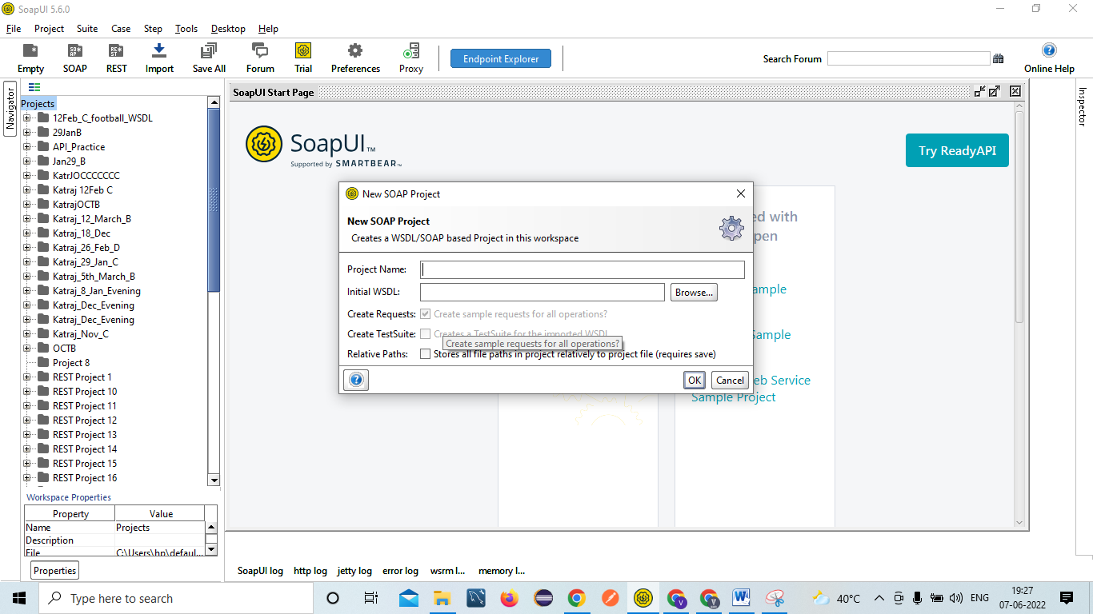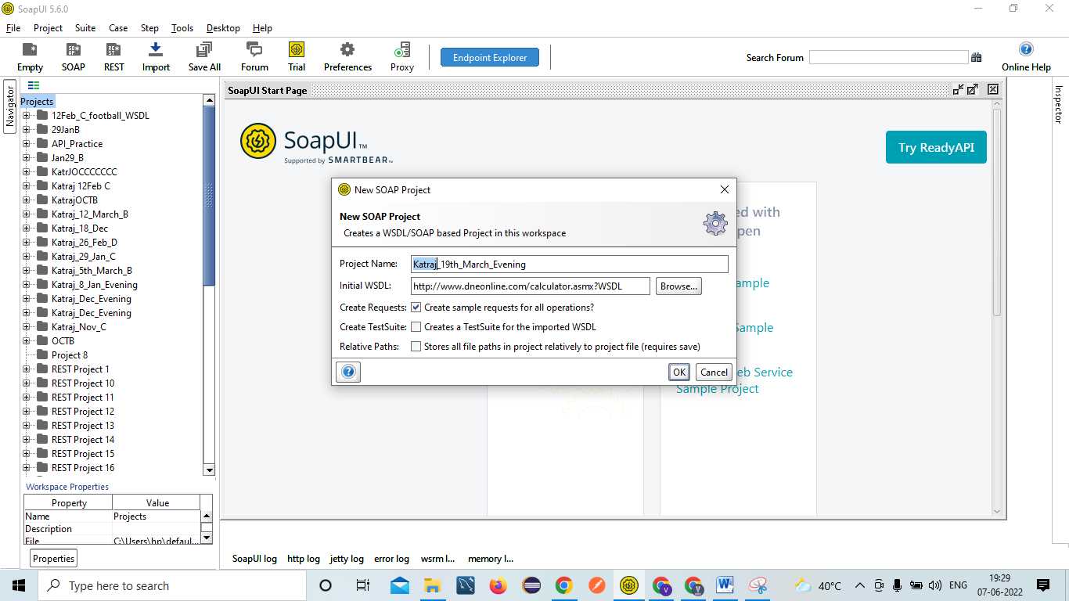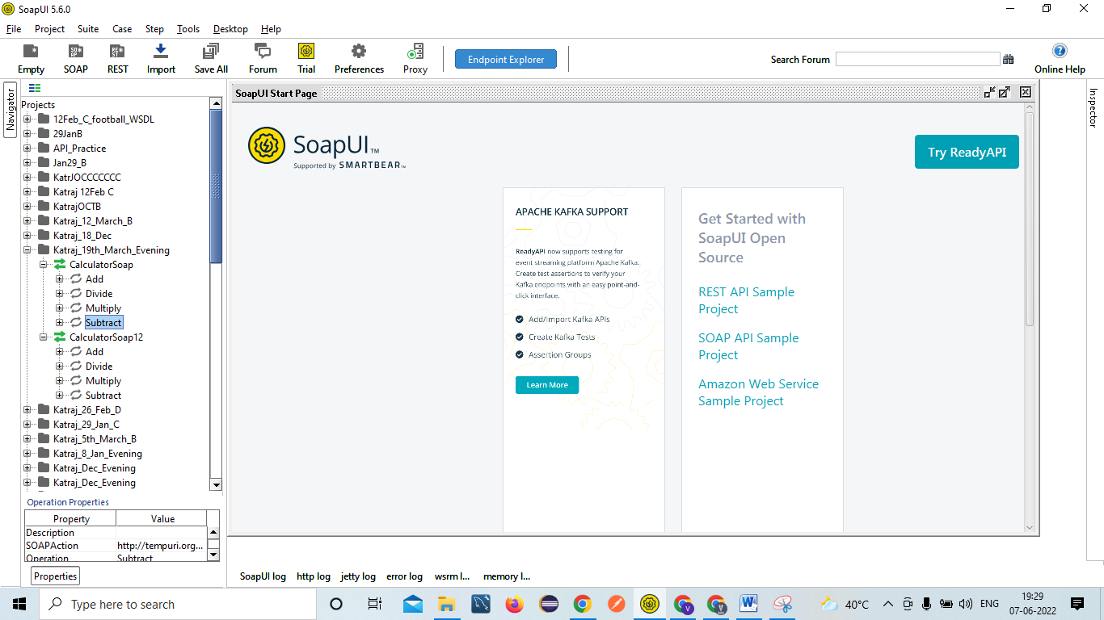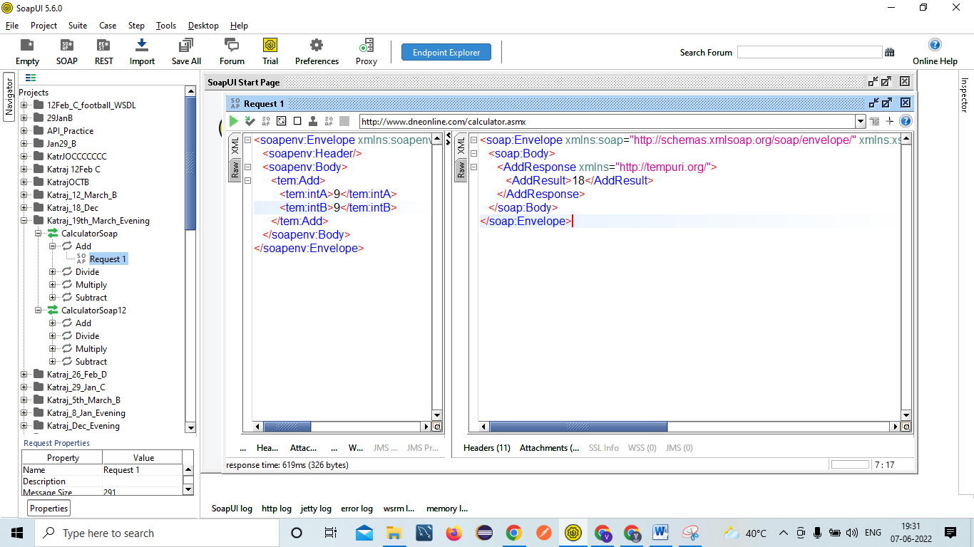

API Testing-
- 2 Types Service
- SOAP service(SOAP UI tool)
- REST service(SOAP UI,POSTMAN)

Paytm – UI/ GUI
Service Travels- Parameter Values
Travels agency/ Provide-Service/
IRCTC - Service
Request
Response
IRCTC main Server

